1. **Consignment Note Notification**

Now the consignment note show all as notification, we need group the consignment note by customer. Example customer A add one date 50 or 100 note system need show the customer details by date

Customer A

22-7-2022 – 50 note

23-7-2022 – 60 note

24-7-2022 – 40 note

Customer B

22-7-2022 – 10 note

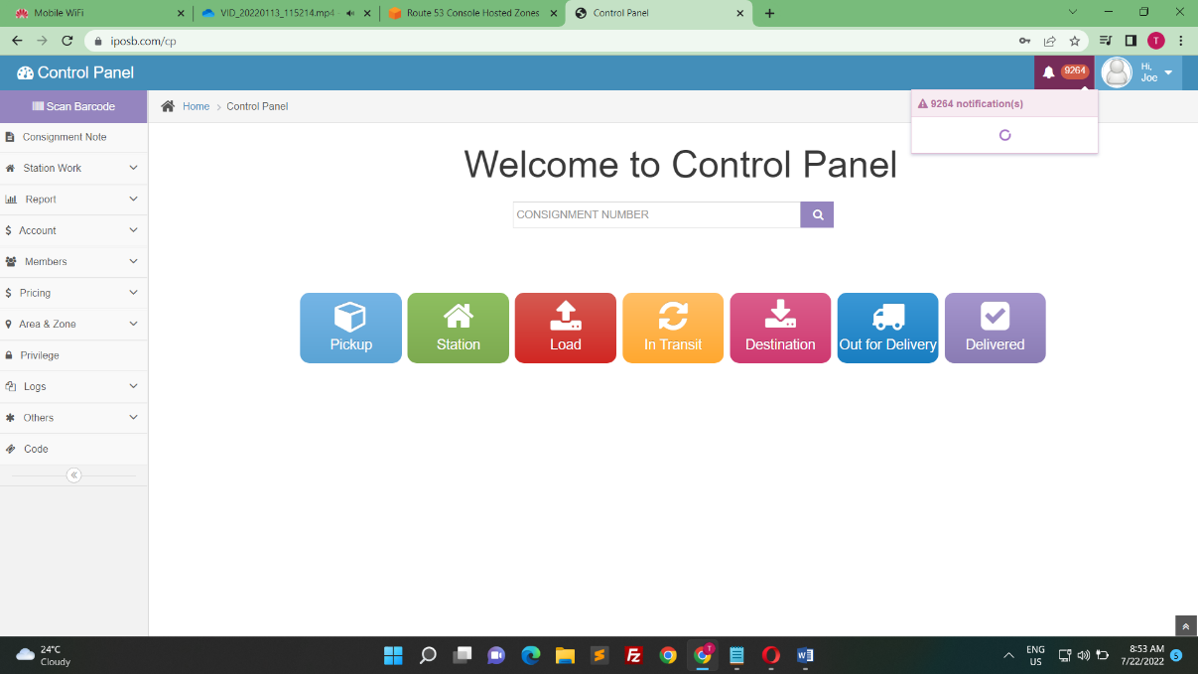When admin click the line of date show the 50 note of the customer

1. **Rider Commission Module**

* Enable admin to set commission for specific rider, area, specific consignment

1. **Manifest - Enhancement**

* Require Choosing partner for different file uploaded
* Require Enabling admin Upload details by excel file
* Require enable Admin to generate invoice

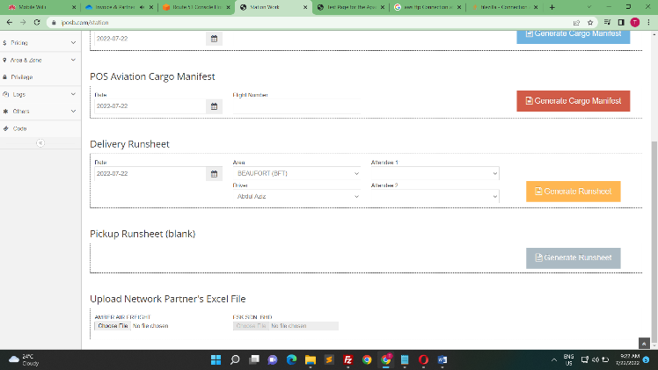

Here now just able to upload AMBER AIR FREIGHT excel. We like to add more partner excel

**4) Partner Login Management Module (Enhancement)**

* Enable Partner to login to view invoice and statement

1. **Member Report**

* Unable view weight in Member report.

1. Customer Group Price

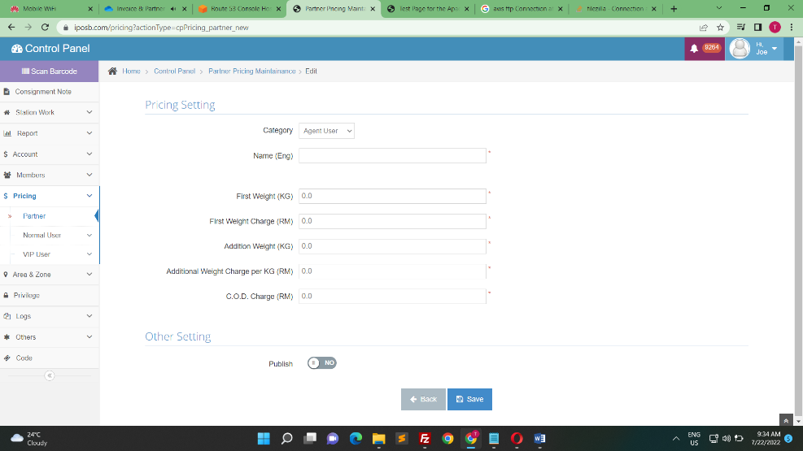

Partner site enable check box for to customer able check which service Partner using.

Customer able set the price for then check box select.

Note we will provide mode details and design for this

1. **Issues Require to Solve**

Note: Please provide all the issue in video file e.g. partner_edit.mp4

Partner edit issue

Filter Issue

Member Issue

Invoice Issue

Loading Issue

